

IT-SEP4C-S18 – Serious Game

Project Description

# The Frangovers

## 

## Karolina Beliharova

## Marek Löwy

## (253810)

## (253652)

# 

# Supervisors

## Kasper Knop Rasmussen

## Jakob Knop Rasmussen

Table of Contents

Background Description 3

Definition of Purpose 4

Problem Statement 4

Delimitation 4

Choice of Models and Methods 4

Time Schedule 5

Risk Assessment 5

Sources of Information 6

# Background Description

A game, as a form of recreation, which can be used for educational purposes, or spare time enrichment, has been known since around 2600 BC (Royal Game of Ur, Iraq). The games generally spread among people has developed to be more complicated from that time on.

Rules, goals challenges and player interactions are some of the examples that became parts of games. Playing against the opponent was more entertaining because it was challenging, required higher skills, and the joy from winning was more satisfying.

To achieve the meaningful game experience, games needed to be defined by rules, to be understood clearly by the players. Wining conditions were needed to determine winner from looser, or to determine draw.

Some games were pushed so far, that certain level of skill and strategy was required to play for each participant. Fulfilling those rules ensures best game experience.

French sociologist Roger Caillois (Caillois, 1953) defined game as an activity that needs to have the following characteristics: fun, separate, uncertainty, non-productive, governed and fictitious.

The first video games can be dated to the early 50s, when the technology became advanced enough for scientists to design simple games and simulations using electronic circuits. Until that point, the computers were mainly used to solve mathematical problems. The discovery of CRT lead to tremendous rise of game development; however, it was not until the 70s and 80s that the games reached the mainstream popularity with arrival of arcade games and gaming consoles.

According to The Conversation, video games have great educational potential in addition to their entertainment value. Games designed for specific problem, or to teach a specific skill have been very successful, since they are motivating, engaging, and provide rewards and chance to improve.

Gameplay involves repeated actions that strengthen the brain cell connections underlying memory and learning. Games as Tetris or Othello activate brain areas which control decision making. Some games require real-time action and activate areas, which control sensory movement.

# Definition of Purpose

The purpose of this project is to create something that will help people with training their memory. It should do this in a form that is entertaining and appealing.

# Problem Statement

Mentality of generations is constantly changing. Current generation thinking has changed drastically over past decades. What was effective and fun in the past seems boring today. We need to find a way to convince young to exercise their brain and memory. We need to find a way to make this training fun and appealing to them, whilst keeping its effectiveness. Preferably the solution should be both looking and sounding nice.

# Delimitation

# Choice of Models and Methods

|  |  |  |
| --- | --- | --- |
| **What**  Partial problem | **Why**  Why study this problem? | **Which**  Which models/theories are expected to be used to solve the problem? |
| How to make game fun to play | Because game that is fun to play will be more appealing to more people | With optimised assets and code, as well as continuous testing during development phase. |
|  |  |  |
|  |  |  |

# 

# Time Schedule

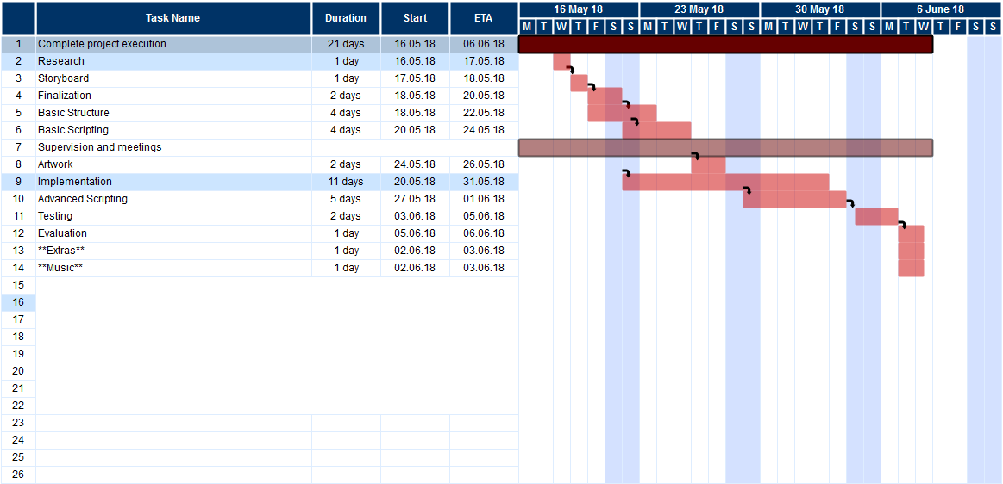

# Risk Assessment

|  |  |  |  |  |  |  |
| --- | --- | --- | --- | --- | --- | --- |
| Risks | Description | L | S | R | Person in Danger | Control recommendations |
| Injury | Misbehaviour | 1 | 1 | 1 | All group members | Ensure that everyone is doing what they should and nothing dangerous |
| more work | new requirements | 2 | 3 | medium | All group members | Have some free time in time schedule, then it will be easier to add more work and hours |
|  |  |  |  |  |  |  |
|  |  |  |  |  |  |  |
|  |  |  |  |  |  |  |

# Sources of Information

Caillois, R. (1953). *Les jeux et les hommes.* Paris: Gallimard. Retrieved from Wikipedia

Available at: [https://en.wikipedia.org/wiki/Game#Roger_Caillois](https://en.wikipedia.org/wiki/Game%23Roger_Caillois)

Playing video games is good for your brain – here’s how. *The Conversation* [online].

Available at: <http://theconversation.com/playing-video-games-is-good-for-your-brain-heres-how-34034>

Wikipedia. *History of video games*. [ONLINE]

Available at: <https://en.wikipedia.org/wiki/History_of_video_games>

Wikipedia. *Game*. [ONLINE]

Available at: <https://en.wikipedia.org/wiki/Game>

ICT Engineering, 2017 Project Description – VIA Engineering Guidelines